
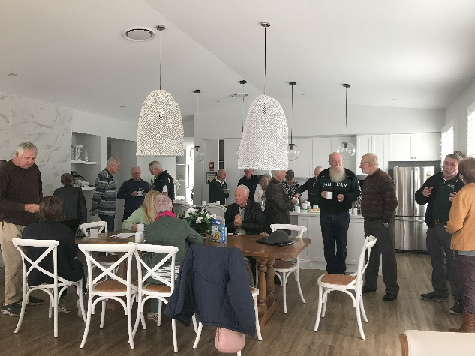
Annual General Meeting
Tuesday 18th August 2026.
The Beach House, 185 Bishop Rd, Beachmere
S 27° 06’ 53.1” / E 153° 03’ 44.4” ……………. UBD page 60/N14
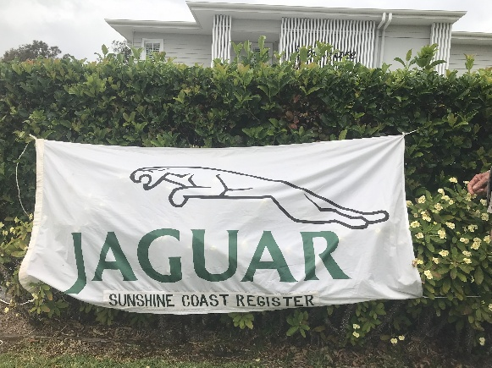
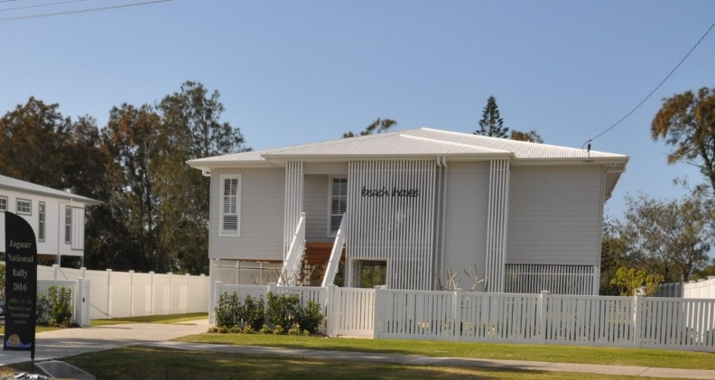

The committee extends a hearty invitation to all members to attend a great social occasion. You will receive our 25/26 financial report and participate in the election of officer bearers for 26/27:
- All positions are vacant and nominations close on 11th August 2026. We have a strong, motivated current committee who will be invited to re-nominate. We also welcome new additions to the committee, please see the Nomination Form – separate attachment.
- There is parking at the back of the property. The Beach house has a lift entry,
- A free Morning Tea will be provided from 10.00 am,
- The AGM will commence at 11.00 am followed by lunch at the Beachmere Hotel.
Please RSVP by 11th August to sc-secretary@jagqld.org.au indicating names attending morning tea/AGM and names for lunch booking at the Beachmere Hotel.

