What's New at SNG Barratt?
Check out what is new to range at SNG Barratt this week...
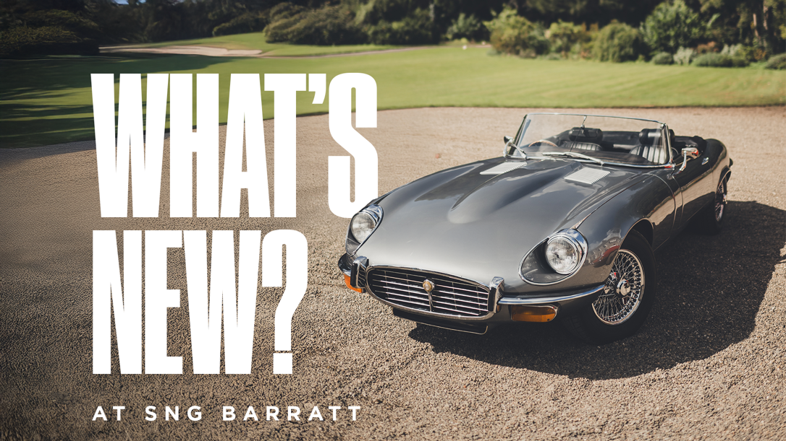
Chequered Flag Horn Push Assembly — E-Type S3 (C33502*/1)
Manufactured at SNG Barratt's Bridgnorth facility, this horn push assembly for the E-Type S3 features the 6-cylinder style chequered flag centre. Produced in-house to original specification, it gives owners the option of this classic period detail: a small touch, but one that speaks directly to the E-Type's motorsport heritage. Click here to view part on website.
Engine Mounting — XF 2009-2015 2.2D (C2Z13435*/1)
A high-quality aftermarket front engine mounting for the 2.2D XF, offering a huge saving against the genuine part. Engine mountings are a common wear item on higher-mileage cars, and this reproduction gives XF owners a cost-effective way to keep the powertrain properly supported without compromising on quality. Click here to view part on website.
Front Vertical Link RH — XJ X351 (C2D33598*)
Completing this week's new additions is a high-quality aftermarket right-hand front vertical link for the X351 XJ, again offering a huge saving compared to genuine. A key component of the front suspension geometry, this reproduction part gives owners of Jaguar's flagship saloon a dependable replacement at a fraction of the main dealer cost. Click here to view part on website.
Can't find what you're looking for? SNG Barratt is constantly producing new and uprated parts for classic and modern Jaguars. If there is a part you cannot find on the website or a part you think SNG Barratt should consider making, don't hesitate to get in touch with the sales team on 01746 765432 or email sales.uk@sngbarratt.com. For more information, visit www.sngbarratt.com.

