What's New at SNG Barratt?
Check out what is new to range at SNG Barratt this week...
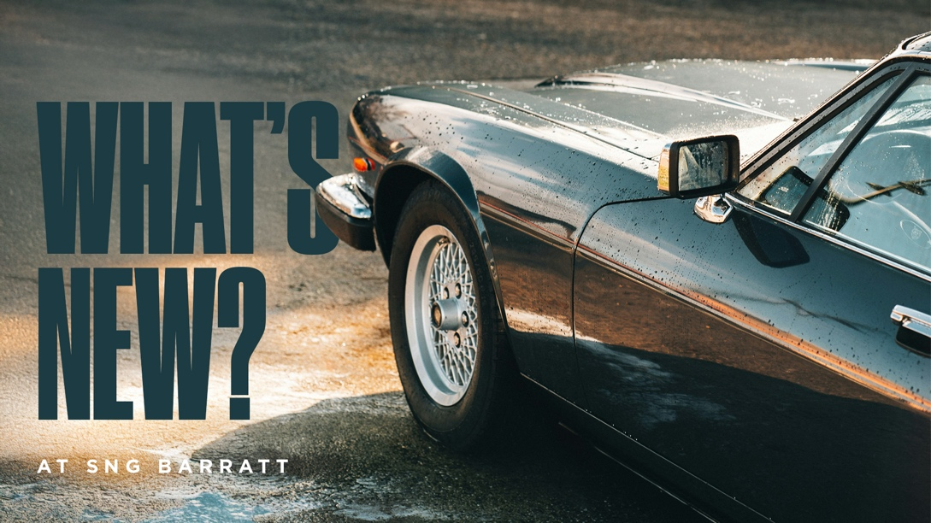
Throttle Potentiometer Upgrade Kit — XJ12 Series 3 / XJ-S (EAC2670U/1)
Our throttle potentiometer upgrade kit replaces aging original units with a modern, more reliable solution, delivering a smooth and consistent signal to the ECU for improved throttle response, drivability, and engine efficiency. By eliminating common wear-related issues such as hesitation, erratic idle, and signal dropouts, it provides a simple, fit-and-forget upgrade that enhances performance and reliability for everyday use or touring. Click here to view part on website.
Rear Bumper Guide Block — XK8 / XKR (HJA6554AB*)
With this part having been made obsolete by the manufacturer, SNG Barratt has stepped in to ensure continuity of supply by producing the rear bumper guide block for the XK8 and XKR entirely in-house. Manufactured to the original specification, owners of these popular modern classics can continue to source this component with confidence, safe in the knowledge that SNG Barratt has them covered. Click here to view part on website.
Seat Lever Sleeve / Knob — E-Type Series 2 (12528*/1)
Also new to range is this seat lever sleeve and knob for the E-Type Series 2, now manufactured from a better quality material to deliver a more authentic finish. A small but important detail in any interior restoration, this upgraded component allows owners to achieve the correct period look without compromise. Click here to view part on website.
Can't find what you're looking for? SNG Barratt is constantly producing new and uprated parts for classic and modern Jaguars. If there is a part you cannot find on the website or a part you think SNG Barratt should consider making, don't hesitate to get in touch with the sales team on 01746 765432 or email sales.uk@sngbarratt.com. For more information, visit www.sngbarratt.com.

