SNG Barratt Press Release

Thursday 14th May 2026

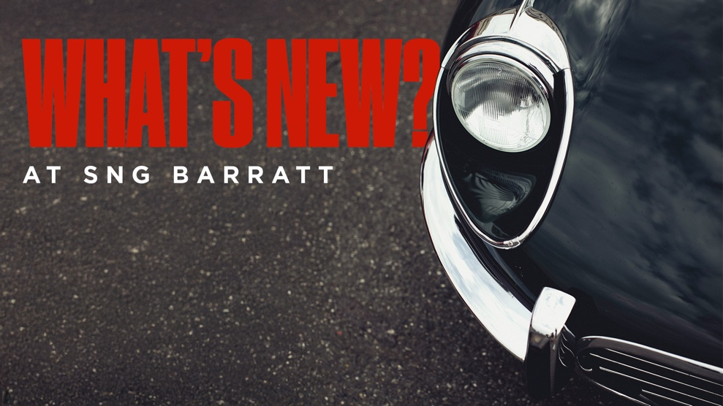

What’s New at SNG Barratt?

Check out what is new to range at SNG Barratt this week…

E-Type 4.2/V12 Brake Master Cylinder Repair Kit (C26767GRK)
Brand new for 2026, SNG Barratt has introduced a Girling brake master cylinder repair kit for the E-Type 4.2 and V12, supplied complete with the piston sub assembly. Designed to service the Girling C26767 brake master cylinder, this kit gives classic E-Type owners everything needed to carry out a thorough, high-quality rebuild. An essential addition to the range for anyone looking to restore or maintain their braking system to the highest standard. Click here to view part on website.

E-Type 4.2/V12 Brake Master Cylinder Reaction Valve Kit (11305G)
Also new from Girling, SNG Barratt has sourced a brake master cylinder reaction valve kit for the E-Type 4.2 and V12. A critical component in maintaining correct brake pedal feel and system performance, this ready-to-fit kit offers E-Type owners a quality, reliable solution for reaction valve replacement. Click here to view part on website.

E-Type 4.2/V12 Brake Master Cylinder Seal Kit (10918G)
Completing the new trio of Girling brake master cylinder parts, SNG Barratt has added a seal and gasket set for the E-Type 4.2 and V12. Supplied as a comprehensive kit, this is the ideal solution for owners carrying out a full master cylinder overhaul, ensuring a proper seal and long-lasting performance. Click he re to view part on website.

Can’t find what you’re looking for? SNG Barratt is constantly producing new and uprated parts for classic and modern Jaguars. If there is a part you cannot find on the website or a part you think SNG Barratt should consider making, don't hesitate to get in touch with the sales team on 01746 765432 or email sales.uk@sngbarratt.com. For more information, visit www.sngbarratt.com.

